**MR. FAREMI ABASS AKANDE**

This lecture note gives intuitive understanding of Elasticity, Hook’s Law, Stress, and Strain, Elastic Limit, and Ultimate Strength.

You should be able to write and apply formulas for calculating Young Young’s modulus, shear modulus, and bulk modulus. And Solve problems involving each of the parameters in the aforementioned objectives.

**ELASTICITY**

**AN ELASTIC BODY** is one that returns to its original shape after a deformation. Examples are: golf ball, rubber band and soccer ball.

**AN INELASTIC BODY** is one that does not return to its original shape after a deformation. Examples are bread and clay.

**COLLISION**

**AN ELASTIC COLLISION** loses no energy. The deformation on collision is fully restored.

**AN INELASTIC COLLISION,** energy is lost and the deformation may be permanent.

**AN ELASTIC SPRING**

A spring is an example of an elastic body that can be deformed by stretching. A restoring force, F, acts in the direction opposite the displacement of the oscillating body.



**HOOKE**

**HOOKE’S LAW**

When a spring is stretched, there is a restoring force that is proportional to the displacement.



The spring constant k is a property of the spring given by:  where the spring constant k is a measure of the elasticity of the spring.

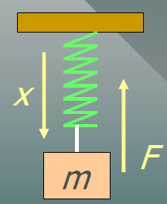

**STRESS AND STRAIN**

Stress refers to the cause of a deformation, and strain refers to the effect of the deformation.

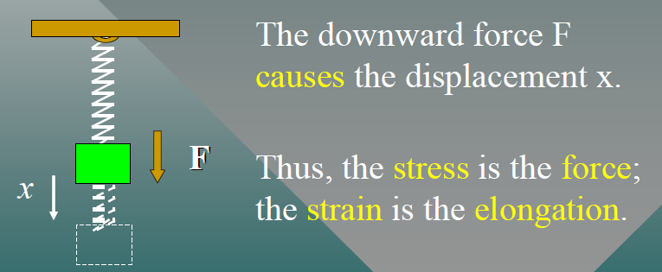

**STRESS** is the ratio of an applied force F to the area A over which it acts.



**TYPES OF STRESS**

**A TENSILE STRESS** occurs when equal and opposite forces are directed away from each other.

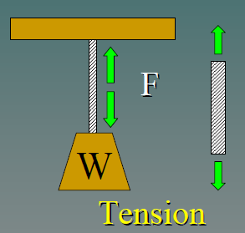

**A COMPRESSIVE STRESS** occurs when equal and opposite forces are directed toward each other.

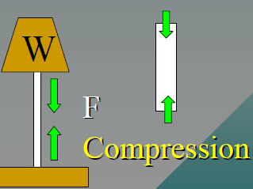

**STRAIN** is the relative change in the dimensions or shape of a body as the result of an applied stress.

 Change in length per unit length; change in volume per unit volume

**LONGITUDINAL STRESS AND STRAIN**

For wires, rods, and bars, there is a longitudinal stress F/ A that produces a change in length per unit length. In such cases

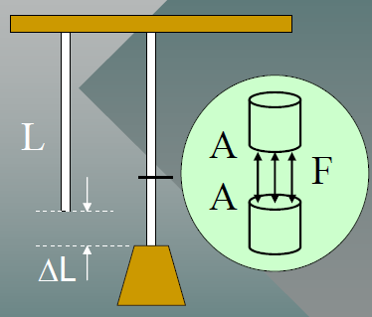

Example 1. A steel wire 10 m long and 2 mm in diameter is attached to the ceiling and a 200-N weight is attached to the end. What is the applied stress?

SOLUTION:



Find the area of the wire first



Example 2. A 10 m steel wire stretches 3.08 mm due to the 200 N load. What is the longitudinal strain?

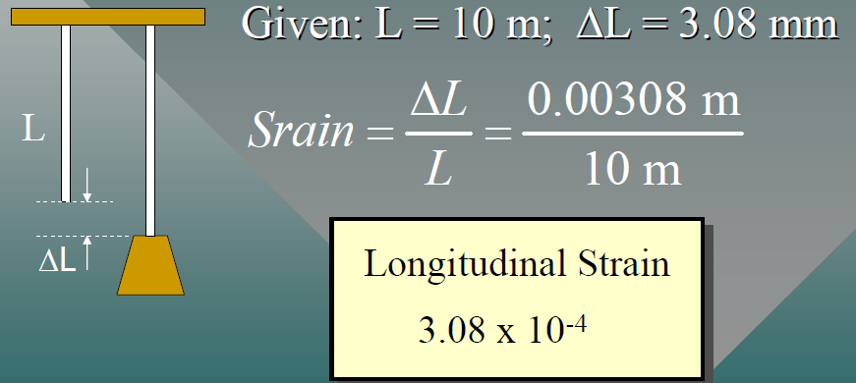

**The Elastic Limit**

The elastic limit is the maximum stress a body can experience without becoming permanently deformed. If the stress exceeds the elastic limit, the final length will be longer than the original.

**The Ultimate Strength**

The ultimate strength is the greatest stress a body can experience without breaking or rupturing.

If the stress exceeds the ultimate strength, the string breaks

Example 3. The elastic limit for steel is 2.48 x 108 Pa. What is the maximum weight that can be supported without exceeding the elastic limit?

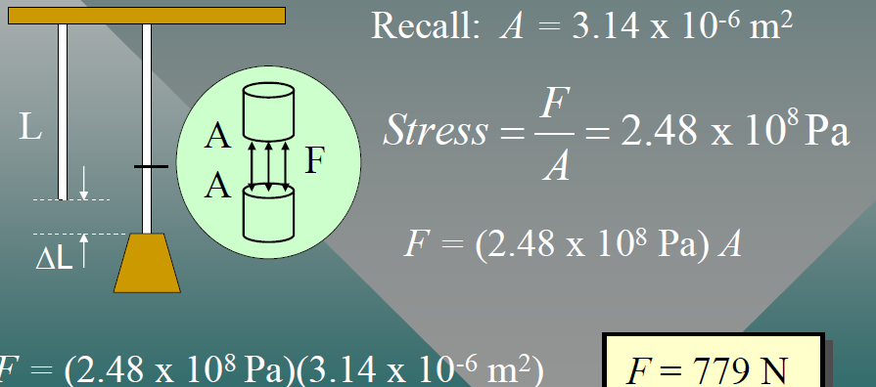

**The Modulus of Elasticity**

Provided that the elastic limit is not exceeded, an elastic deformation (strain) is directly proportional to the magnitude of the applied force per unit area (stress)



Example 4. If the stress applied to a steel wire is 6.37 x 107 Pa and the strain was 3.08 x 104.

Find the modulus of elasticity for steel.

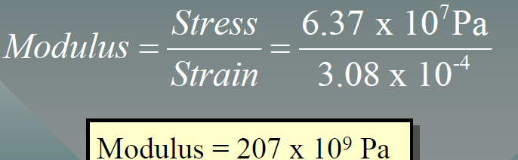

**YOUNG’S MODULUS**

This longitudinal modulus of elasticity is called Young’s Modulus and is denoted by the symbol Y.

For materials whose length is much greater than the width or thickness, we are concerned with the longitudinal modulus of elasticity, or Young Young’s Modulus (Y).

Young’s modulus = $\frac{longitudinal stress}{longitudinal strain}$



Example 4: Young’s modulus for brass is 8.96 x 1011 Pa . A 120N weight is attached to an 8m length of brass wire; find the increase in length, if the diameter is 1.5 mm

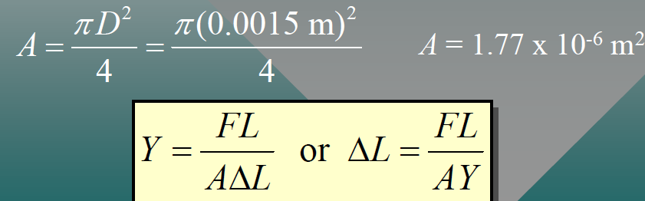

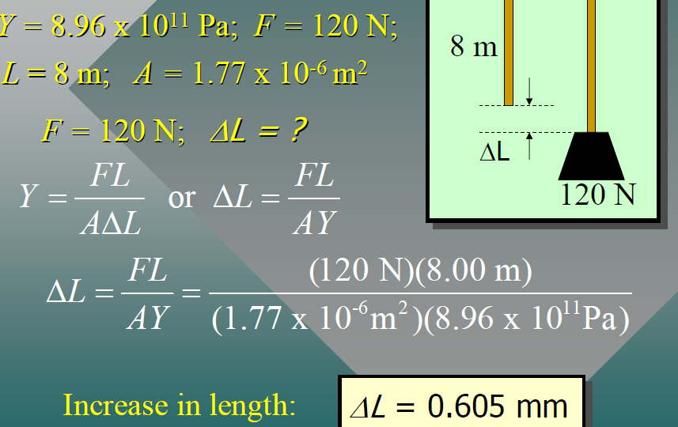

**Shear Modulus**

A shearing stress alters only the shape of the body, leaving the volume unchanged. For example, consider equal and opposite shearing forces F acting on the cube below:

NB: A material having a large shear modulus is difficult to bend.

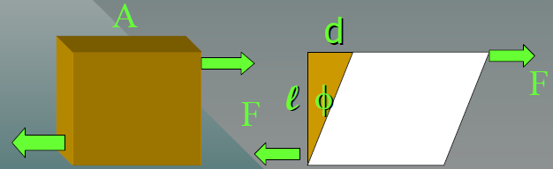

The shearing force F produces a shearing angle ɸ. The angle ɸ (expressed in radians radians) is the strain and the stress is given by F/ A as before.

DEFINITION: The shear modulus “S” is defined as the ratio of the shearing stress *F/ A* to the shearing strain ɸ.







Example 5. A steel stud ( S = 8.27 x 1010Pa) 1 cm in diameter projects 4 cm from the wall. A 36,000N shearing force is applied to the end. What is the defection “d” of the stud?

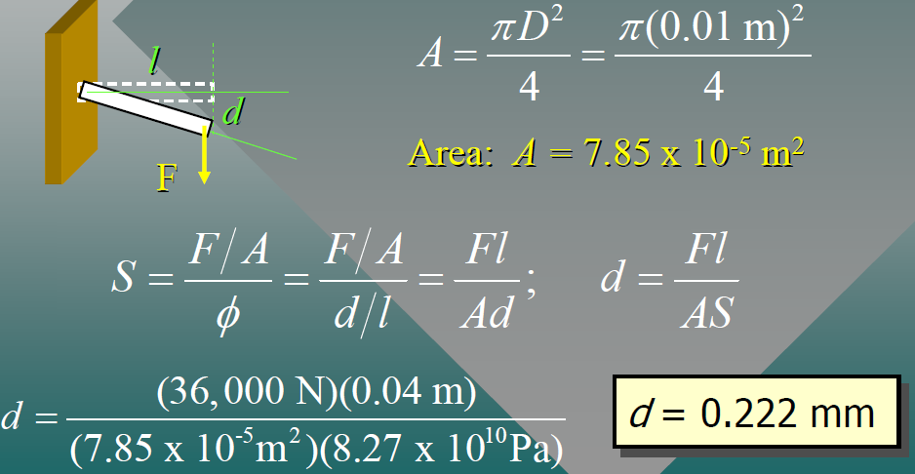

Volume Elasticity

Not all deformations are linear. Sometimes an applied stress F/ A results in a decrease of volume volume. In such cases, there is a bulk modulus B of elasticity.

NB: A material with a large bulk modulus is difficult to compress.

The bulk modulus is negative because of decrease in V.

**NOTES ON MODULI**

1. Solids have Young’s, Bulk, and Shear moduli
2. Liquids and gases have only bulk moduli, they will not undergo a shearing or tensile stress
3. The liquid or gas would flow instead.

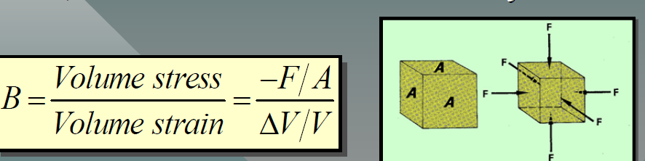



Example 7. A hydrostatic press contains 5liters of oil. Find the decrease in volume of the oil if it is subjected to a pressure of 3000 kPa . (Assume that B = 1700 MPa .)

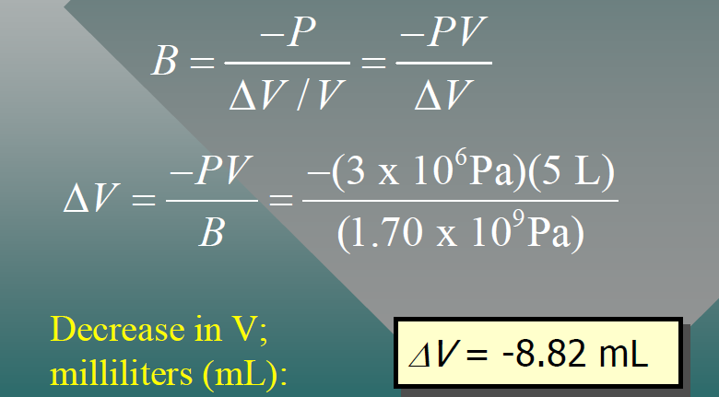

THANKS